**1. Creating an EC2 Instance:**

**Step 1: Sign in to AWS Management Console**

* Log in to your AWS account and go to the EC2 dashboard.

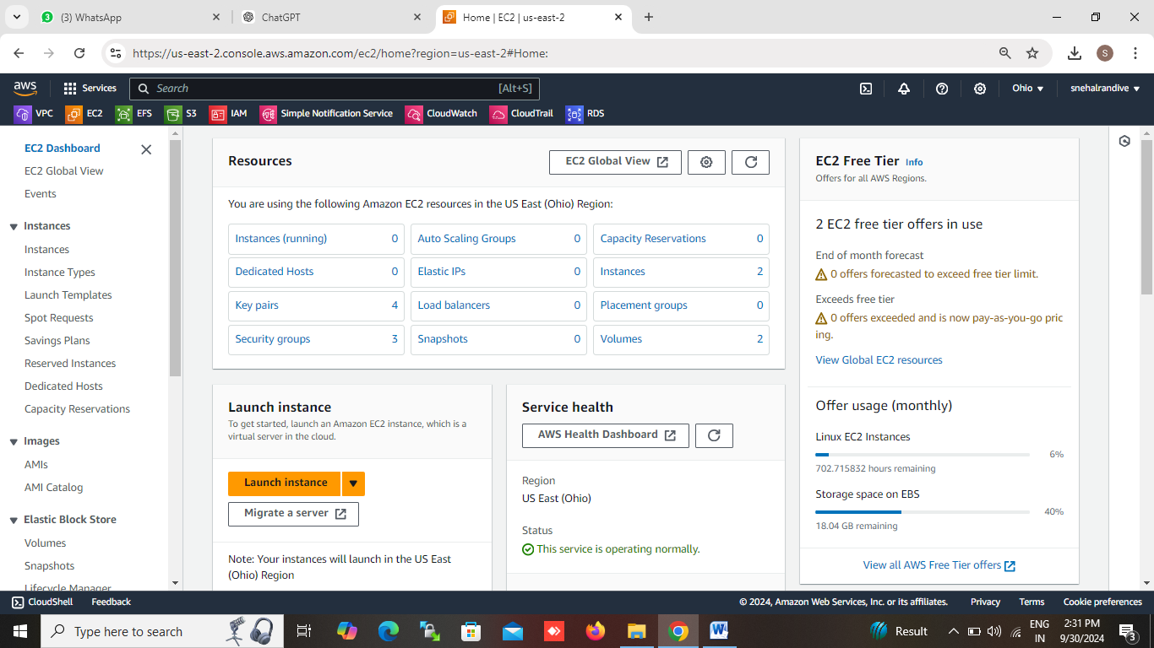

**Step 2: Launch Instance**

* From the EC2 dashboard, click on the **"Launch Instance"** button.

**Step 3: Choose an Amazon Machine Image (AMI)**

* An AMI is a pre-configured OS image (e.g., Amazon Linux, Ubuntu, Windows Server). Select the one that fits your needs.
  + For Linux: Choose **Amazon Linux 2 AMI** (Free Tier eligible).
  + For Windows: Select **Windows Server** AMI.

**Step 4: Choose an Instance Type**

* EC2 offers different instance types based on CPU, memory, and storage needs. If you're on the free tier, select **t2.micro**.

**Step 5: Configure Instance Details**

* Choose the number of instances, network settings (VPC, subnet), and whether you want auto-scaling.
  + Use default settings unless you have specific requirements.

**Step 6: Add Storage**

* Define the storage size (e.g., 8 GB for root volume).
  + For testing, the default 8 GB General Purpose SSD is sufficient.

**Step 7: Add Tags**

* Add tags to categorize your instance (optional). Example: Key = "Name", Value = "My-EC2-Instance".

**Step 8: Configure Security Group**

* A security group acts as a virtual firewall.
  + Add rules to allow specific traffic:
    - SSH (for Linux): Type = SSH, Port = 22, Source = Anywhere (for remote access).
    - RDP (for Windows): Type = RDP, Port = 3389, Source = Anywhere.
  + You can limit access to a specific IP by setting it in the Source field.

**Step 9: Review and Launch**

* Review your configuration, then click **Launch**.

**Step 10: Create a Key Pair**

* Choose **Create a new key pair**. This key will be used to access your instance via SSH or RDP.
  + Download the .pem file and keep it safe.

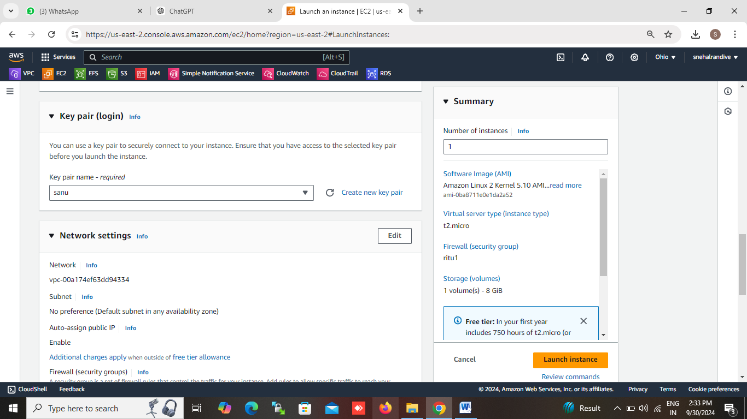

**Step 11: launch EC2 instance**

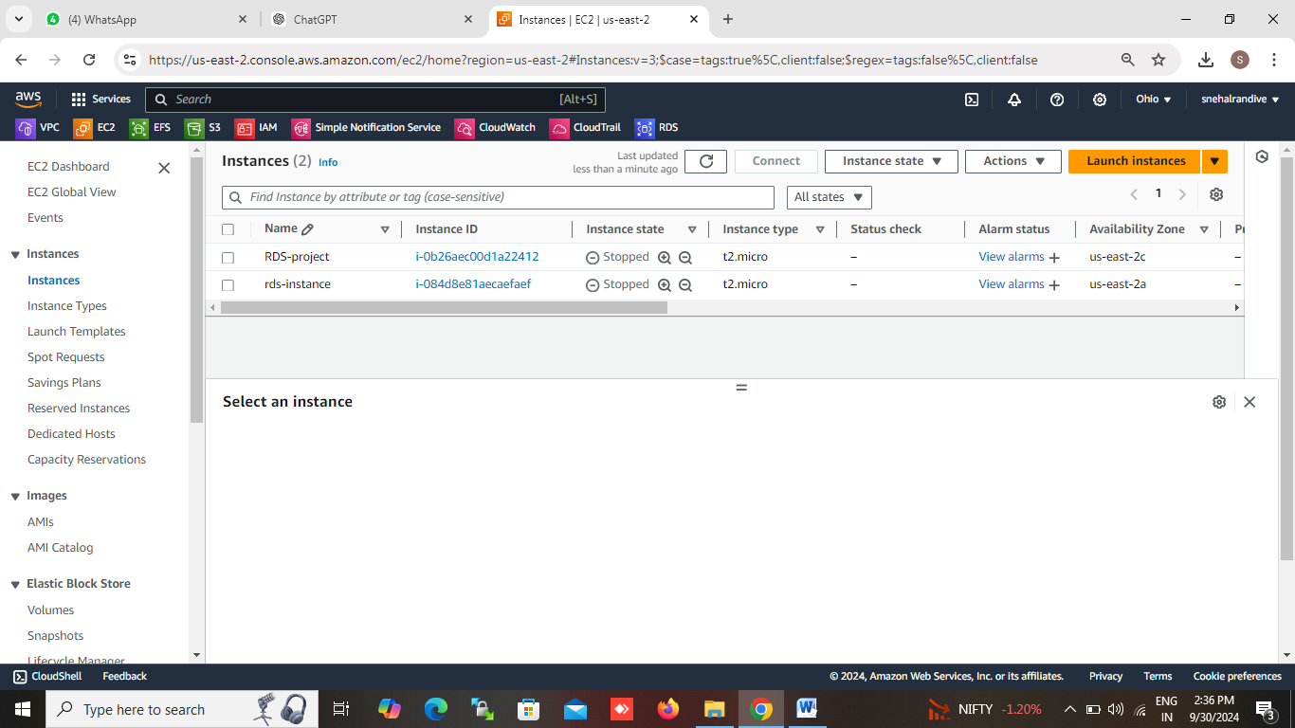

**2. Connecting to Your EC2 Instance:**

**Step 1: Connect via SSH (Linux/Ubuntu Instance)**

* On your local machine, use the downloaded .pem key and run:

chmod 400 /path-to-your-key.pem

ssh -i /path-to-your-key.pem ec2-user@your-public-ip

• Replace /path-to-your-key.pem with the correct path to your key file.

• Use the public IP address of your EC2 instance.

